Supervised by Dr.Tamam Al- Sarhan

|  |  |
| --- | --- |
| Dania Ibrahim Adnan Sawalha | 0201553 |
| Rand Ahed Al-Assaf | 0201194 |
| Dareen Nabeel Al-Deeb | 0205291 |
| Aseel Jamal Sharsheer | 0203882 | |

Skin diseases classification model

Deep learning course project 2024

Contents

Abstract 3

Introduction 3

Literature review 4

Research 1 4

Research 2 4

Our Project 4

Experiments 5

Data description 5

Data preprocessing 5

Data Normalization 5

Class imbalanced 5

Training augmentation 6

Machine Learning algorithm 6

About the Model 6

Target audience 6

Medical Researchers 6

Healthcare institutions and Hospitals 6

Key Components in the model 7

Resize Image 7

Image Preprocessing 7

ResNet 50 Backbone 7

Convolutional layer 7

Pooling layer 7

Fully connected layer 7

Modified fully connected layer. 8

Loss Function 9

Optimizer 9

Activation Functions 9

Results 9

Custom FC Layer 10

Data Augmentation 10

Random Resized Crop 10

Random Rotation 10

Color Jitter 10

Random Horizontal Flip 11

Random Affine Transformation 11

Normalization 11

Limitations 12

Imbalanced data 12

Lack of data 12

Conclusion 12

References 13

Figure 1 12

2Results visualization 13

# Abstract

This deep learning project focuses on the classification of skin diseases using the ResNet50 architecture, a powerful convolutional neural network known for its effectiveness in image recognition tasks. The aim was to leverage machine learning to enhance early detection and classification of various skin conditions, thereby improving medical diagnostics and patient care. The project utilized the Fitzpatrick 17k dataset, comprising 988 images across eight categories annotated with Fitzpatrick skin types. Key components included image preprocessing techniques such as normalization and augmentation, alongside advanced model features like dropout regularization and ensemble learning with custom fully connected layers. The model achieved a validation accuracy of 78%, highlighting its potential utility in clinical settings. This research contributes to the ongoing efforts in integrating AI into dermatological practice, offering a promising approach to address challenges in skin disease diagnosis and treatment.

# Introduction

The discipline of dermatology includes both medical and surgical components, and it deals with illnesses of the skin, hair, and nails. Dermatologists treat illnesses in the broadest sense as well as some minor skin, scalp, hair, and nail issues. The complex nature of human skin's jaggedness, tone, hair presence, and other mitigating characteristics make it one of the most unpredictable and challenging terrains to mechanically synthesize and analyze. Skin conditions are more serious than other illnesses. Skin conditions can be brought on by viruses, bacteria, sensitivities, or microbes, among other things. Skin diseases can alter the skin's natural texture and color. Skin conditions are typically spreadable, long-lasting, and occasionally lead to skin cancer. A skin illness requires more time for diagnosis and treatment, as well as additional financial and medical expenses for the sufferer. The type and stage of the skin condition may need to be accurately determined through costly laboratory testing, making the diagnosis challenging. The development of photonics and laser-based medical technology has sped up and improved the accuracy of skin disease diagnosis. However, to stop the development and spread of skin diseases, early detection is essential. The expense of such a diagnosis is still high and restricted. Consequently, we suggest a diagnosis method based on image processing. We have specifically decided to train our model on the Fitzpatrick dataset using the ResNet to offer a lightweight, high-performance solution.

# Literature review

## Research 1

**Skin Disease Detection Using Deep Learning**

In this study, the researchers used the smartphone's camera to their advantage to diagnose patients by using the device's image processing skills. The development of an application to aid in the detection of skin diseases is the focus of the suggested system. It detects illnesses by utilizing machine learning and image processing technologies. Machine learning and image processing make up the two components of the system. Applying different filters to the photos to reduce noise and improve uniformity is the focus of the image processing section. Before processing the image, the undesired parts must be removed, or the output efficiency will be negatively impacted. Data processing and result creation are the focus of the machine learning section. They employed neural networks in their project to get the desired outcomes.

## Research 2

**A machine learning approach for skin disease detection and classification using image segmentation**.

This work provides an automated image-based method for diagnosing and categorizing skin problems that use machine learning classification. Computational approaches will be used to analyze, process, and relegate picture data to consider the many different characteristics of the photos that are being processed. Skin photographs are first filtered to remove undesirable noise from the image and then processed to enhance the picture's overall quality. It is possible to extract features from an image using advanced techniques such as Convolutional Neural Network (CNN), classify the picture using the SoftMax classifier's algorithm, and provide a diagnostic report as an output.

## Our Project

**Skin diseases classification**

This project intends to significantly enhance healthcare by giving people a useful tool for early skin condition categorization. We want to provide users with knowledge, enable early detection, and enhance the general wellbeing of people with skin-related issues by combining state-of-the-art deep learning techniques with a user-centric design.

Using the ResNet50 architecture for the Fitzpatrick dataset to train our model is intentionally chosen to provide a low-weight, high-performance solution. The utilization of deep learning techniques, particularly the ResNet50 architecture, ensures a powerful yet lightweight solution for efficient deployment.

# Experiments

## Data description

We present the Fitzpatrick 17k dataset which is a collection of images from two online dermatology atlases annotated with Fitzpatrick skin types by a team of humans. We train a deep neural network to classify skin conditions solely from images, and we evaluate accuracy across skin types. The images are sourced from two online open-source dermatology atlases: 12,672 images from DermaAmin and 3,905 images from Atlas Dermatologic. However, We Had to reduce them to 988 images due to the Imbalanced dataset. This carefully chosen collection the foundation for the success of our AI skin disease project is formed through focusing on variety, relevance to common dermatological conditions, and respect to existing categorization systems during the decision-making process.

Based on the most prevalent dermatological problems found in these two data sources, we choose which photos to annotate, focusing on the following 8 categories of skin conditions: scabies 138, taeniasis 107, lupus erythematosus 108,nematode infection 126,pityriasis rubra pilaris 175,folliculitis 102,psoriasis 104 and porokeratosis actinic 127.

A group of human annotators from Scale AI have annotated the photos with Fitzpatrick skin type classifications. The Fitzpatrick labeling system is a six-point rating system that was first created to categorize skin responsiveness to the sun and modify clinical treatment based on skin phenotype.

## Data preprocessing

### Data Normalization

For every input feature to have a consistent scale and to keep some characteristics from controlling the learning process, normalization is an essential step. This normalization is especially crucial when dealing with images since it helps with convergence while neural networks are being trained.

### Class imbalanced

Class rebalancing becomes important when there is a significant imbalance in the distribution of instances across different classes. In training, the model may become biased toward the majority class due to imbalanced datasets, which might hinder the model's capacity to generalize effectively to minority classes.

### Training augmentation

Through the addition of changes to the dataset, this strategy is essential in improving the resilience and generalization of the model, by introducing variations to the dataset.

# Machine Learning algorithm

## About the Model

In this project the model was used ResNet50, which stands for Residual Network with 50 layers. ResNet50 is a type of convolutional neural network (CNN) architecture known for its deep structure and use of residual connections, which enable training of very deep networks effectively and widely used that has demonstrated state-of-the-art performance on various computer vision tasks, including image classification, object detection, and segmentation. ResNet50 is famous for its deep architecture that can effectively handle the vanishing gradient problem during training, allowing the successful training of very deep neural networks. ResNet50 consists of 50 layers, including convolutional layers, batch normalization layers, ReLU activation functions, and skip connections. When ResNet50 is being trained, the main result of the project is the classification of sickness skin images. Principal output combining medical and technological factors together is the project's objective.

## Target audience

### Medical Researchers

The AI skin illness project may be of interest to medical researchers because of its ability to further our understanding of skin disorders, trends, and patterns.

### Healthcare institutions and Hospitals

Hospitals and other healthcare facilities may be interested in integrating AI systems for the identification of skin diseases into their larger infrastructure of medical technology. Better patient care and resource optimization may result from this.

## Key Components in the model

### Resize Image

When scaling an image, the image is resized to (224,224) by this line. The image that needs to be resized is the first input, and the format's desired output image size (width, height) is the second argument.

### Image Preprocessing

To make sure that the input values to a machine learning model fall within the same numerical range, normalization is a necessary step in the production of images.

Normalization_value = raw- value / 255.0

In neural network training, image preprocessing which includes normalization and scaling to (224,224) guarantees data consistency and numerical stability. While normalization reduces pixel values to a range of 0 to 1, improving training stability and model convergence, resizing gets images ready for input into a network.

## ResNet 50 Backbone

### Convolutional layer

These layers are responsible for detecting intricate patterns and features in skin images. They analyze different aspects of the skin, such as texture, color, and shape, at various levels of detail.

### Pooling layer

These layers perform down sampling on the extracted features. By reducing the spatial dimensions of the feature maps while retaining essential information about skin characteristics, these layers make the model robust to changes in the position or size of skin features within the input images. This robustness ensures that the model can accurately classify skin types regardless of their location or scale in the images.

### Fully connected layer

The fully connected layers in the ResNet-50 backbone don't directly classify skin types in your modified model. Instead, they take all the detailed information about the skin from earlier layers and simplify them into a simpler form. This simpler form captures the most important characteristics of the skin images, making it easier for the later layers to figure out which skin type it is.

### Modified fully connected layer.

#### Linear layers

perform a series of transformations on the extracted features to map them to the output space for skin type classification. These transformations help the model learn discriminative representations of different skin types based on the extracted features.

#### PRelU activation functions

By introducing non-linearity into the model, PReLU activation functions enable the capture of complex patterns and relationships among different skin features. This nonlinearity allows the model to effectively distinguish between subtle variations in skin types.

#### Batch Normalization Layers

These layers normalize the activations of the preceding layer, promoting faster convergence during training and reducing the likelihood of overfitting. By stabilizing the learning process, batch normalization enhances the generalization ability of the model, leading to more accurate skin classification.

#### Dropout Layer

Dropout regularization is applied to prevent overfitting by randomly deactivating a fraction of neurons during training. In our skin classification model, the dropout layer helps prevent the model from relying too heavily on specific features or patterns present in the training data, thereby improving its ability to generalize to unseen skin images.

#### Log SoftMax Layer

The Log SoftMax layer computes the logarithm of the SoftMax probabilities for each skin type class. By transforming the output scores into log-probabilities, this layer facilitates training with cross-entropy loss.

### Loss Function

Description: in this project the "Cross-Entropy Loss" also known as log loss, is a commonly used loss function for classification problems, particularly in scenarios where the model predicts class probabilities.

Is used to find the optimal solution by adjusting the weights of a machine learning model during training.

The objective: is to minimize the error between the actual and predicted outcomes.

Cross-Entropy Loss= −∑*i*​**y**true,*i*​⋅log(**y**pred,*i*​)

### Optimizer

The optimizer used is "Adamax" which is an adaptive learning rate optimization algorithm designed for training deep neural networks that adapts the learning rate for each parameter during training.

Aiming to minimize the cross-entropy loss and improve the model's performance on the skin type classification task.

*mt*​=*β*1​⋅*mt*−1​+(1−*β*1​)⋅*gt*​

*vt*​=max(*β*2​⋅*vt*−1​,∣*gt*​∣)

### Activation Functions

Uses ReLU as Activation Functions. It is the most widely used activation function. Chiefly implemented in hidden layers of the Neural network.

ReLu is less computationally expensive than tanh and sigmoid because it involves simpler mathematical operations.

*f*(*x*)=max(0,*x*)

# Results

The device that is used in this project is CPU because of the limitation of the resources, so the model and class weights are converted into a PyTorch tensor and moved to the specified device. Class weights are used to address class imbalance in the dataset by assigning higher weights to less frequent classes during loss calculation. Moving them to the device ensures compatibility with the model's device.

The data split 75:25 and the random state is 0. The batch size is 256 and the number of workers is 4. The optimizer that is used is “Adamax”, the learning rate is 0.001, weight decay is 0.2, while the loss function was categorical cross entropy. The Learning Rate Scheduler which adjusts the learning rate during training is "ReduceLROnPlateau", this scheduler monitors a specified metric (the maximum validation accuracy), the quantity has been maximized. In addition, the scheduler reduces the learning rate when the monitored quantity stops improving for a certain number of epochs (patience), and verbose=True enables logging of learning rate adjustments.

The implementation of ensemble of ResNet50 models with custom fully connected (FC)layers:

Inside the loop, each bagging model is initialized by creating an instance of the ResNet-50 model pre-trained on ImageNet.

## Custom FC Layer

Two linear (fully connected) layers, first one uses 512 units while the second use 1024 units, with ReLU activation (PReLU) and batch normalization (BatchNorm1d), first one use 512 units while the second use 1024 units, applied after each linear layer. A dropout layer with a dropout probability of 0.3 introduces regularization, reducing overfitting. The final linear layer with the number of output units equal to the number of classes in the classification task, followed by a log SoftMax activation along dimension 0. This FC layer serves as the classifier head of each ResNet-50 model, transforming the features extracted by the convolutional layers into class probabilities.

## Data Augmentation

### Random Resized Crop

Randomly crops the input image to a specified size and aspect ratio. This helps the model learn to focus on different parts of the image during training and improves robustness to object location and scale variations.

### Random Rotation

Randomly rotates the input image by a specified angle. This helps the model learn to recognize objects from different viewpoints and orientations.

### Color Jitter

Randomly adjusts the brightness, contrast, saturation, and hue of the input image. This helps the model learn to be invariant to changes in lighting conditions and color variations.

### Random Horizontal Flip

Randomly flips the input image horizontally with a probability of 0.5. This helps the model learn to be invariant to horizontal reflections and improves robustness to left-right orientation variations.

### Random Affine Transformation

Randomly applies affine transformations such as scaling, shearing, and translation to the input image. This helps simulate real-world distortions and improves the model's ability to generalize to unseen variations in the data.

### Normalization

Normalizes the pixel values of the input image to have a mean of [0.485, 0.456, 0.406] and a standard deviation of [0.229, 0.224, 0.225]. Normalization helps stabilize training by ensuring that input features are centered around zero and have a similar scale.

The CSV files in the code are used to store metadata and labels associated with images. These CSV files are loaded, preprocessed, and used to create custom datasets, which are then used for training and validation of deep learning models.

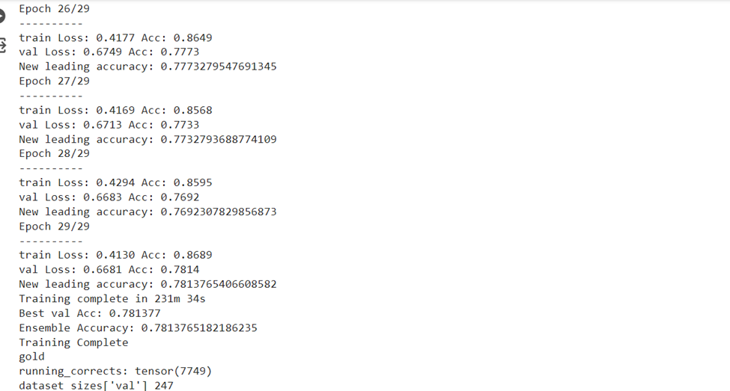

Figure 1

**validation Loss**: 0.6681.

**Ensemble Accuracy**: 0.7813765182186235.

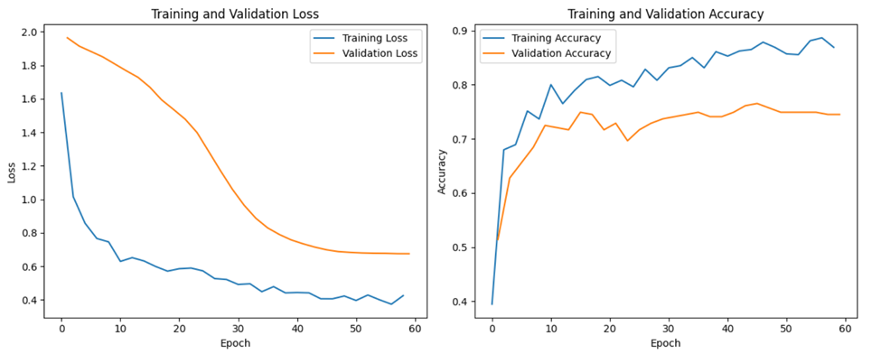

2Results visualization

# Limitations

## Imbalanced data

One issue was unbalanced data, which resulted in a large difference in the number of images between different categories in the dataset.

This affected the performance of the model as it was difficult for the model to recognize the few images from a particular category which it could not train properly and as a result, the accuracy was reduced.

## Lack of data

Without enough data, it would be impossible to get comprehensive knowledge, which might lead to false or partial judgments and an incorrect objective achievement. Also, there wasn't enough data because what was supplied was unreliable and inconsistent, making analysis challenging. The results' relevance was diminished by biases that also corrupted the data.

# Conclusion

In this paper we suggest a diagnosis method based on image using ResNet50 and a dataset with processing. We collected images of a dataset of clinical skin disease images, including 988 real-world images from 8 categories. We notice that there is overfitting in the dataset we used so the test accuracy was 78% with loss function was 1.5. In this project the dataset that has been used contains eight classes (scabies 138 images, tungiasis 107 images, lupus erythematosus 108 images, nematode infection 126 images, pityriasis rubra pilaris 175 images, folliculitis 102 images, psoriasis 104 images and porokeratosis actinic 127 images) contains 988 picture that was trained in 30 epochs using ResNet50 model which contains 10 layers.

# References

1. Alenezi, Nawal. (2019). A Method of Skin Disease Detection Using Image Processing And Machine Learning. Procedia Computer Science. 163. 85-92. 10.1016/j.procs.2019.12.090.
2. V. B. Kumar, S. S. Kumar and V. Saboo, "Dermatological disease detection using image processing and machine learning," 2016 Third International Conference on Artificial Intelligence and Pattern Recognition (AIPR), Lodz, Poland, 2016, pp. 1-6, doi: 10.1109/ICAIPR.2016.7585217.
3. Groh, Matthew & Harris, Caleb & Soenksen, Luis & Lau, Felix & Han, Rachel & Kim, Aerin & Koochek, Arash & Badri, Omar. (2021). Evaluating Deep Neural Networks Trained on Clinical Images in Dermatology with the Fitzpatrick 17k Dataset.
4. Jehad,Amin ,AlKattash. Dramamine. [https://www.dermaamin.com/site/.](https://www.dermaamin.com/site/)
5. Samuel, Freire da Silva. Atlas dermatologic. [http://atlasdermatologico.com.br/.](http://atlasdermatologico.com.br/)
6. Howard, Andrew G., Mark Sandler, Grace Chu, Liang-Chieh Chen, Bo Chen, Mingxing Tan, Weijun Wang, Yukun Zhu, Ruoming Pang, Vijay Vasudevan, Quoc V. Le and Hartwig Adam. “Searching for MobileNetV3.” 2019 IEEE/CVF International Conference on Computer Vision (ICCV) (2019): 1314-1324.
7. T. Parashar, K. Joshi, R. R. N, D. Verma, N. Kumar and K. S. Krishna, "Skin Disease Detection using Deep Learning," 2022 11th International Conference on System Modeling & Advancement in Research Trends (SMART), Moradabad, India, 2022, pp. 1380-1384, doi: 10.1109/SMART55829.2022.10047465.
8. Debelee, T.G. Skin Lesion Classification and Detection Using Machine Learning Techniques: Systematic Review. Diagnostics 2023, 13, 3147. <https://doi.org/10.3390/diagnostics13193147>
9. Al-Sabaawi, Aiman & Ibrahim, Hassan & Mohsin, Zinah & Al-Amidie, Muthana & Alzubaidi, Laith. (2020). Amended Convolutional Neural Network with Global Average Pooling for Image Classification.
10. Howard, Andrew G., Menglong Zhu, Bo Chen, Dmitry Kalenichenko, Weijun Wang, Tobias Weyand, Marco Andreetto and Hartwig Adam. “MobileNets: Efficient Convolutional Neural Networks for Mobile Vision Applications.” ArXiv abs/1704.04861 (2017): n. pag.
11. Sharma, Atul and Phonsa, Gurbakash, Image Classification Using CNN (April 24, 2021). Proceedings of the International Conference on Innovative Computing & Communication (ICICC) 2021, Available at SSRN: <https://ssrn.com/abstract=3833453> or <http://dx.doi.org/10.2139/ssrn.3833453>
12. Brittany Dulmage, Kyle Tegtmeyer, Michael Z. Zhang, Maria Colavincenzo, Shuai Xu,A Point-of-Care, Real-Time Artificial Intelligence System to Support Clinician Diagnosis of a Wide Range of Skin Diseases,Journal of Investigative Dermatology
13. Khosravi, Bardia & Weston, Alexander & Nugen, Fred & Mickley, John & Maradit Kremers, Hilal & Wyles, Cody & Carter, Rickey & Taunton, Michael. (2023). Demystifying Statistics and Machine Learning in Analysis of Structured Tabular Data. The Journal of Arthroplasty. 38. 10.1016/j.arth.2023.08.045.
14. <https://github.com/mattgroh/fitzpatrick17k/blob/main/ita_fitzpatrick_analysis.ipynb>
15. Mai, Duc-Tho & Ishibashi, Koichiro. (2021). Small-Scale Depthwise Separable Convolutional Neural Networks for Bacteria Classification. Electronics. 10. 3005. 10.3390/electronics10233005.
16. Brittany Dulmage, Kyle Tegtmeyer, Michael Z. Zhang, Maria Colavincenzo, and Shuai Xu. A Point-ofCare, RealTime Artificial Intelligence System to Support Clinician Diagnosis of a Wide Range of Skin Diseases. Journal of Investigative Dermatology, page S0022202X20321679, Oct. 2020
17. Adewole S. Adamson and Avery Smith. Machine Learning and Health Care Disparities in Dermatology. JAMA Dermatology, 154(11):1247, Nov. 2018.
18. M Shamsul Arifin, M Golam Kibria, Adnan Firoze, M Ashraful Amini, and Hong Yan. Dermatological disease diagnosis using color-skin images. In 2012 international conference on machine learning and cybernetics, volume 5, pages 1675–1680. IEEE, 2012
19. Sandler, Mark & Howard, Andrew & Zhu, Menglong & Zhmoginov, Andrey & Chen, Liang-Chieh. (2018). MobileNetV2: Inverted Residuals and Linear Bottlenecks. 4510-4520. 10.1109/CVPR.2018.00474.
20. Groh, Matthew & Harris, Caleb & Daneshjou, Roxana & Badri, Omar & Koochek, Arash. (2022). Towards Transparency in Dermatology Image Datasets with Skin Tone Annotations by Experts, Crowds, and an Algorithm. Proceedings of the ACM on Human-Computer Interaction.